Single posts

1. The Trading Iceberg
Easy money
Big profits
High win rates

WHAT PEOPLE SEE

Losses
Failures

REALITY
Hard work
Commitment

2. A loss can never ruin a trader but it is the size of a loss that can ruin him.
Manage your risks, manage your losses!

3. What most traders think trading is What trading actually is
A quick and smooth ride
A bumpy and challenging ride

4. WITHDRAW your profits regularly
Not withdrawing your profits for a long time can really manipulate your mind in thinking that forex trading is like a game.
Withdraw your profits periodically to feel that those figures on your screen translate to actual money.
5. Things that professional traders do:
- Continuously learn, improve, and adapt.
- Control their emotions.
- Wait for the setup instead of forcing trades.
- Focus on maintaining an overall high win percentage rather than winning a few trades.
6. FOMO traders vs. Disciplined traders
Disciplined Traders | Traders with FOMO
Conduct analysis, follow their plan | Follow rumours, trade with no solid mindset
Set a reliable risk-reward ratio | Use high leverages, do not consider the potential of downside
Trade with fixed stop-loss and take-profit targets | Enter the trades abruptly, panic, close out position, and repeat
Keep a trading journal, track their results | Keep no track record

7. There are only four ways your trades should be closed:
- With a Large win
- With a Small win
- With a Small loss
- With Breakeven
8. Having an exit strategy is as important as the entry plan. If you are not sure how to secure the returns, you will keep losing despite good analysis.
Be clear about your exit plan before entering a position!!
9. 5 ways to avoid losing money in forex:
- Start small
- Work with a reputable broker
- Do your homework
- Strictly follow the risk management rules
- Practice on a demo account
10. Trade WHAT YOU SEE ON THE CHARTS, Not WHAT YOU WISH FOR
Trade according to the actual information shown by market rather than depending on your hunches and wishful thinking.

11. Remember that just because your trade hits the profit target does not necessarily mean you analysis was perfect. And just because it hits the stop loss, does not necessarily imply that your analysis was bad.
That’s because market involves a number of ever-changing factors that can cause unexpected and abrupt price fluctuations many times.

12. Trading is:
10% Buying
10% Selling
Patience is the key. To lose patience is to lose the battle.
13. TRADING CHECKLIST:
- I am following my strategy and rules 
- I know the risks before entering this trade
- I am forcing this trade 
- I have an exit strategy prepared
- I am acting on my feelings and not as per the market is telling

14. DO YOU KNOW?

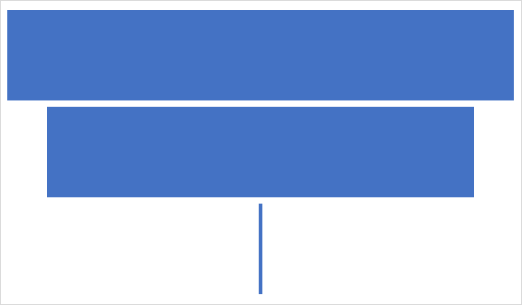
95% people start trading under a “get rich instantly” illusion
80% quit within months or maximum two years
Only 1% stay in the game after 5 years

15. PRICE “BREAK” & “RETEST” TRADING

RETEST & PREVIOUS RESISTANCE BECOMES NEW SUPPORT

BREAK OF RESISTANCE, PRICE FORMING A NEW HIGH

16. Bullish candlesticks
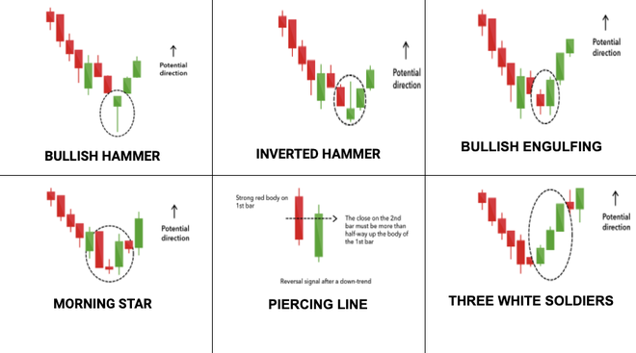

17. Your ONLY competition in the forex market is
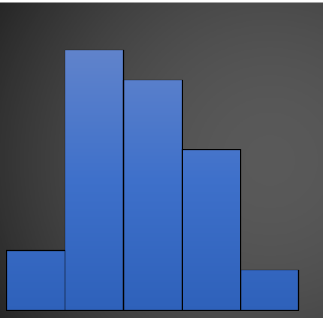

FOMO
GREED
LACK OF KNOWLEDGE
PANIC
OVER-CONFIDENCE

18. SCALING of positions
Scaling is a risk management-based trading technique where traders add MORE buy/sell orders as the price moves in their favour.
Scaling “buy” positions will look like that:
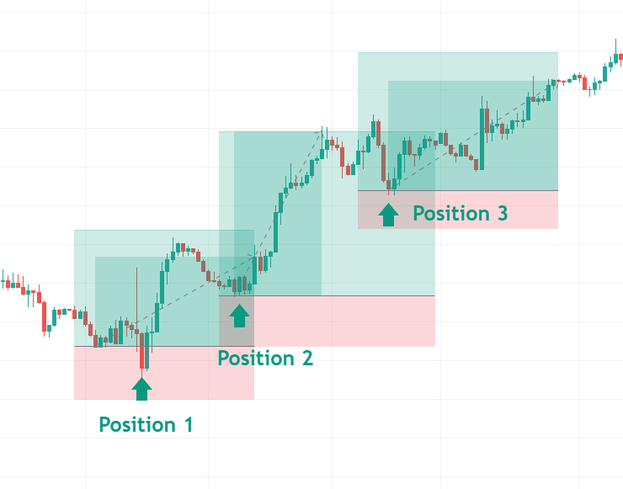

19. Three ways to enter a “Breakout” trade

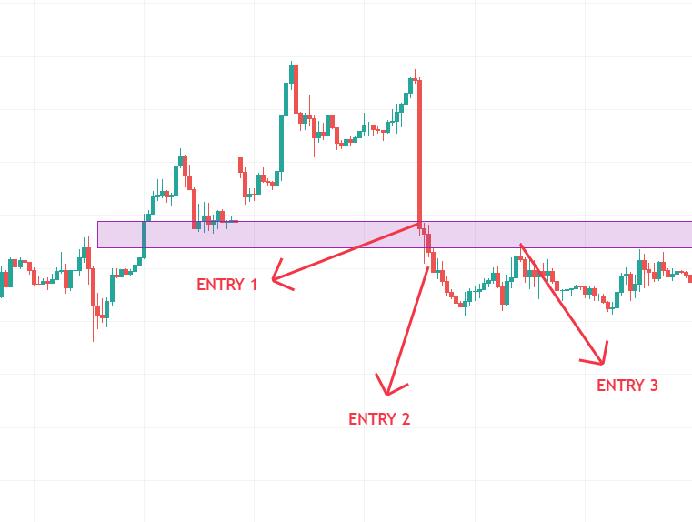
ENTRY 1: Aggressive traders enter immediately after the breakout.
ENTRY 2: Typical traders enter after the confirmation of breakout. (Wait for a “candle close” confirming the breakout)
ENTRY 3: Conservative traders enter after the retest of breakout.

20. Three deadly O’s of trading:
- Overtrading
- Overconfidence
- Overleveraging
- Overriding stoploss
- Overexposure

